- \(…)\Set-up robot\Pick-up
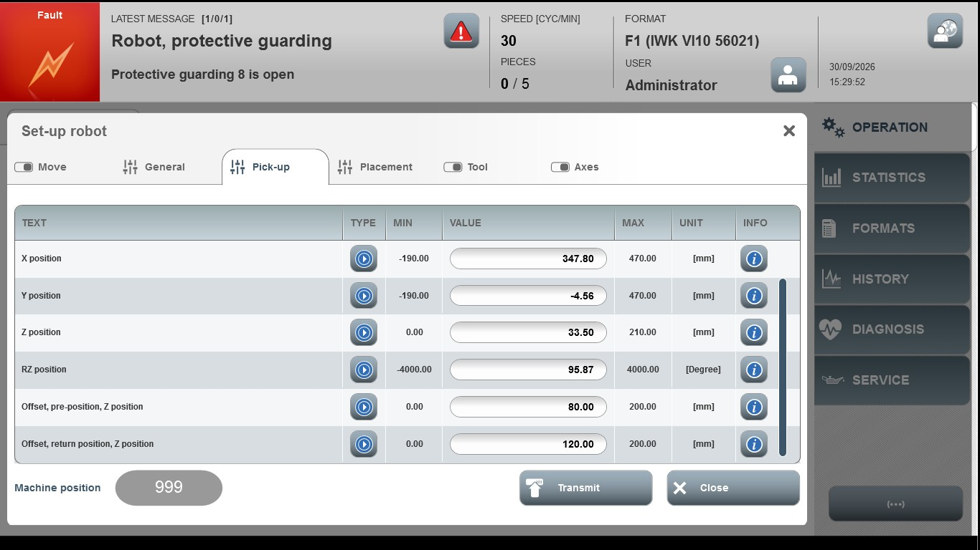
Acceptance criterion | Limits | Pass / Fail: Dev-No. | Date | Initials
Screen matches screenshot | N / A
X position | -190.00 … 470.00
Y position | -190.00 … 470.00
Z position | 0.00 … 210.00
RZ position | -4000.00 … 4000.00
Offset, pre-position, Z position | 0.00 … 200.00
Offset, return position, Z position | 0.00 … 200.00

